# BANK DATABASE

**Question**

(**Week3**)

Branch (branch-name: String, branch-city: String, assets: real)

BankAccount(accno: int, branch-name: String, balance: real)

BankCustomer (customer-name: String, customer-street: String,

customer-city: String)

Depositer(customer-name: String, accno: int)

loan (loan-number: int, branch-name: String, amount: real)

1.Create the above tables by properly specifying the primary keys and the foreign keys.

2.Enter at least five tuples for each relation.

3.Display the branch name and assets from all branches in lakhs of rupees and rename the assets column to 'assets in lakhs'.

4.Find all the customers who have at least two accounts at the same branch (ex.SBI_ResidencyRoad).

5.create a view which gives each branch the sum of the amount of all the loans at the branch.

**Schema diagram:**

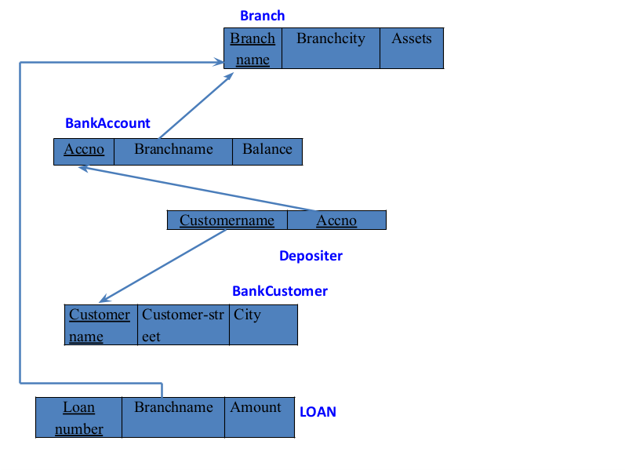

**Create database**

create database bank1;

use bank1;

**create table**

create table branch (

branch_name varchar(25),

branch_city varchar(15),

assets int,

primary key (branch_name)

);

create table bank_account (

accno int,

branch_namevarchar(25),

balance int,

primary key (accno),

foreign key (branch_name) references branch(branch_name)

);

create table bank_customer (

customer_namevarchar(10),

customer_streetvarchar(25),

customer_cityvarchar(15),

primary key (customer_name)

);

create table depositer (

customer_namevarchar(10),

accno int,

primary key(customer_name, accno),

foreign key (customer_name) references bank_customer(customer_name),

foreign key(accno) references bank_account(accno)

);

create table loan (

loan_number int,

branch_namevarchar(25),

amount int,

primary key (loan_number),

foreign key (branch_name) references branch(branch_name)

);

**Structure of the table**

DESC bank_account;

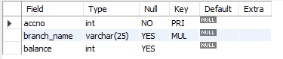

DESC branch;

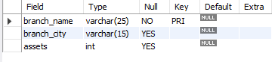

DESC bank_customer;

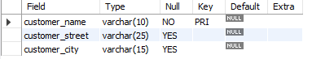

DESC depositer;



DESC loan;

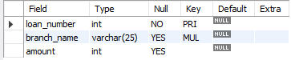

**Inserting values to the table**

insert into branch values('SBI_Chamrajpet', 'Bangalore', 50000);

insert into branch values('SBI_ResidencyRoad', 'Bangalore', 10000);

insert into branch values('SBI_ShivajiRoad', 'Bombay', 20000);

insert into branch values('SBI_ParliamentRoad', 'Delhi', 10000);

insert into branch values('SBI_Jantarmantar', 'Delhi', 20000);

select * from branch;

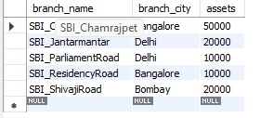

insert into bank_accountvalues(1, 'SBI_Chamrajpet', 2000);

insert into bank_accountvalues(2, 'SBI_ResidencyRoad', 5000);

insert into bank_accountvalues(3, 'SBI_ShivajiRoad', 6000);

insert into bank_accountvalues(4, 'SBI_ParliamentRoad', 9000);

insert into bank_accountvalues(5, 'SBI_Jantarmantar', 8000);

insert into bank_accountvalues(6, 'SBI_ShivajiRoad', 4000);

insert into bank_accountvalues(8, 'SBI_ResidencyRoad', 4000);

insert into bank_accountvalues(9, 'SBI_ParliamentRoad', 3000);

insert into bank_accountvalues(10, 'SBI_ResidencyRoad', 5000);

insert into bank_accountvalues(11, 'SBI_Jantarmantar', 2000);

select * from bank_account;

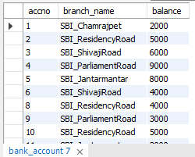

insert into bank_customer values ('Avinash', 'Bull_Temple_Road', 'Bangalore');

insert into bank_customer values ('Dinesh', 'Bannergatta_Road', 'Bangalore');

insert into bank_customer values ('Mohan', 'National_College_Road', 'Bangalore');

insert into bank_customer values ('Nikhil', 'Akbar_Road', 'Delhi');

insert into bank_customer values ('Ravi', 'Prithviraj_Road', 'Delhi');

select * from bank_customer;

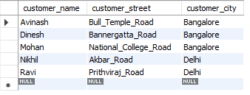

insert into depositervalues('Avinash', 1);

insert into depositervalues('Dinesh', 2);

insert into depositervalues('Nikhil', 4);

insert into depositervalues('Ravi', 5);

insert into depositervalues('Avinash', 8);

insert into depositervalues('Nikhil', 9);

insert into depositervalues('Dinesh', 10);

insert into depositervalues('Nikhil', 11);

select * from depositer;

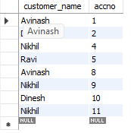

insert into loan values(1, 'SBI_Chamrajpet', 1000);

insert into loan values(2, 'SBI_ResidencyRoad', 2000);

insert into loan values(3, 'SBI_ShivajiRoad', 3000);

insert into loan values(4, 'SBI_ParliamentRoad', 4000);

insert into loan values(5, 'SBI_Jantarmantar', 5000);

select * from loan;

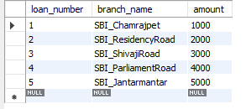

**Queries**

1). Display the branch name and assets from all branches in lakhs of rupees and rename the assets column to 'assets in lakhs'.

select branch_name,(assets/100000) as assets_in_lakhs from branch;

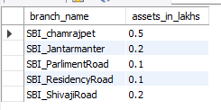

2).Find all the customers who have at least two accounts at the same branch (ex.SBI_ResidencyRoad).

select d.customer_name from depositer d,

Bank_account b where b.branch_name='SBI_RESIDENCYROAD'

and d.ACCNO=b.accno group by d.customer_name

having count(d.accno)>=2;

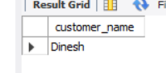

3). create a view which gives each branch the sum of the amount of all the loans at the branch.

create view sum_of_loan1 as select branch_name, sum(amount) from loan group by branch_name;

select * from sum_of_loan1;

